**MBA643A: Midsemester Exam (Take Home)**

* Priya Gole (200727)

Snapshots of one simulation is attached in the doc.

1.What are the budget estimates using the probabilistic model? How are these estimates compared with the point estimate provided in Table 1?

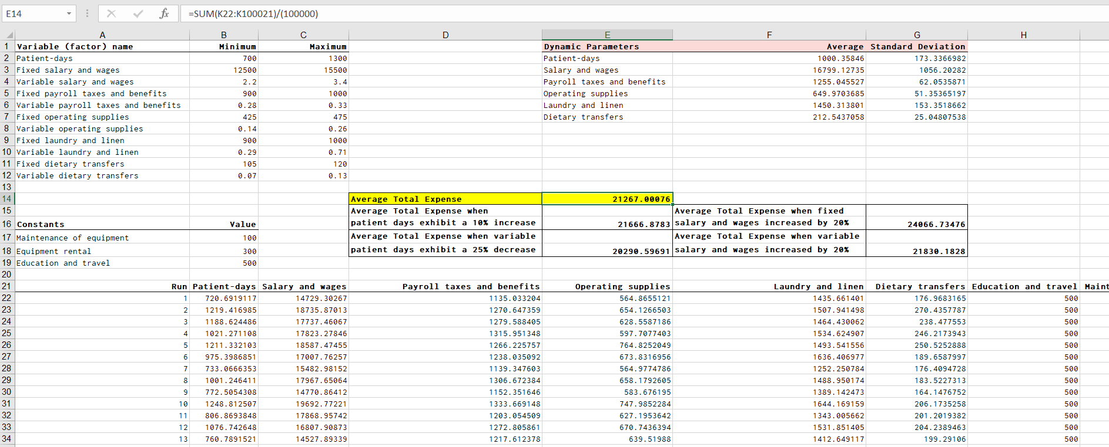

The average of the budget estimation using probabilistic model for one of the simulations is 21267.00076.The budget in the table 1 is deterministic while these estimates are probabilistic which gives us a better estimate of our budget.

2. Quantify and tabulate the standard deviations associated with averages of all dynamic parameters of the model?

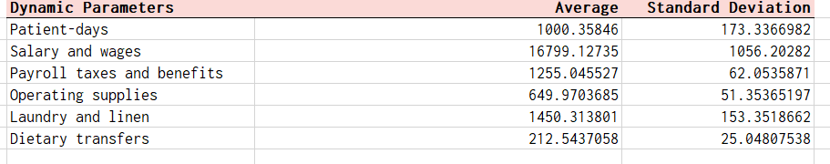

3. Estimate the budgetary requirements for the Medical-Surgical department when the patientdays exhibit a 10% increase?

Simulation for the same is done.

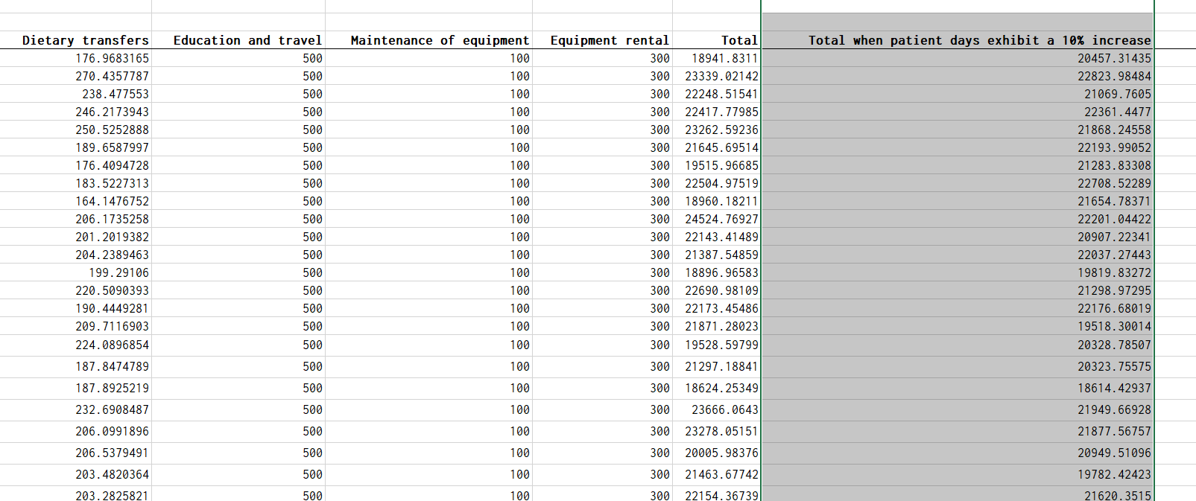

4. Similarly, what would be the budgetary estimates for the department, if the patient days exhibit a negative growth of 25%?

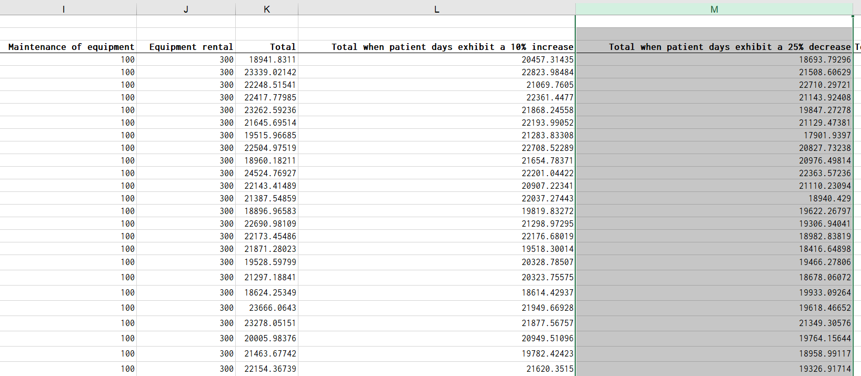

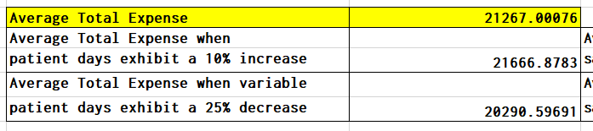

5. What are the budget estimates if the entire simulation was conducted as a single experiment with 100000 replications?

The snap shot of first few runs is shown below.

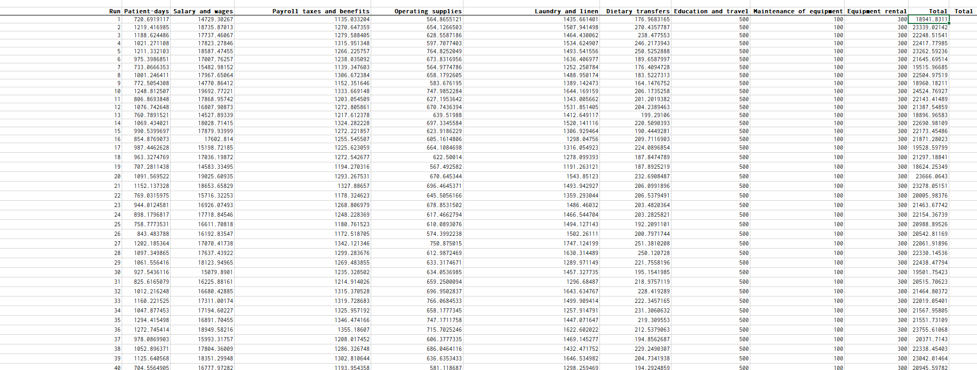

We get the budget estimate of 21267.00076

6. What is the impact of a 20% increase in the fixed salary and wages component in the final budget?

Simulation for the same is done.

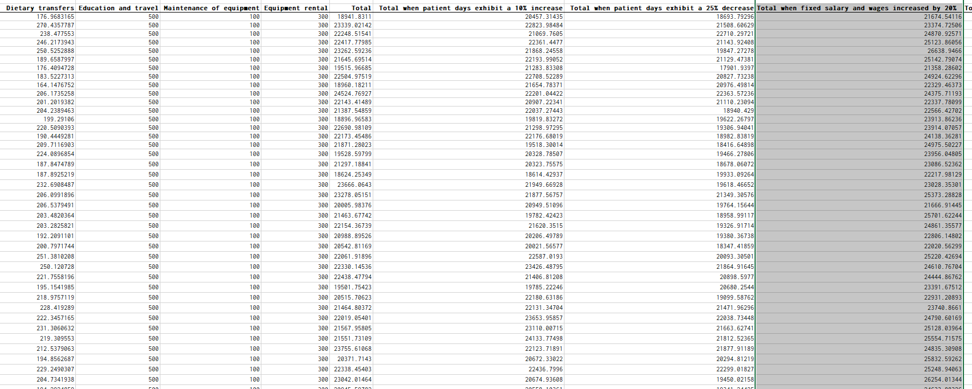

7. Instead of increasing the fixed salary and wages component by 20%, the hospital has proposed a 20% increase on the variable salary and wages component. How will it impact the final budget estimates?

Simulation for the same is done.

